Fuse Service Works and BPM Suite Integration Demo How to Guide

This project fully automates the install of JBoss BPM Suite and on a separate EAP instance JBoss FSW products. It will demonstrate the various use cases when working with these two products.
Use Case 1 Design Time Governance
The First Use Case is using Design Time Governance for Service Life Cycle Management. This will be split into two parts:
A. Using DTGov with the BPMS Customer Project
B. Using DTGov with the FSW Switchyard Application Project
Use Case 2 Switchyard Application calling a Business Process:
The Switchyard application will call the REST API from the camel route.
Use Case 3 Business Process calling a Switchyard Application
The business process will call the switchyard application through a SOAP Service

Overview of Demonstration

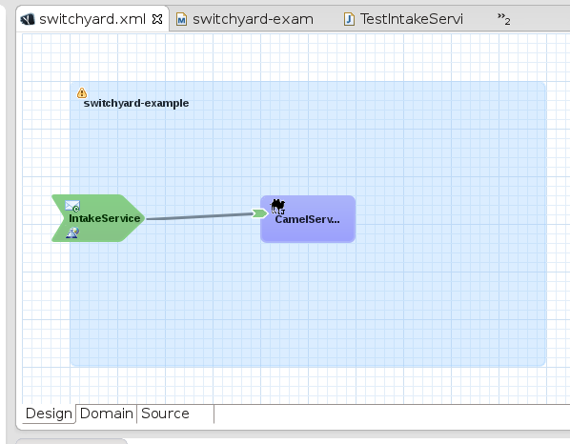
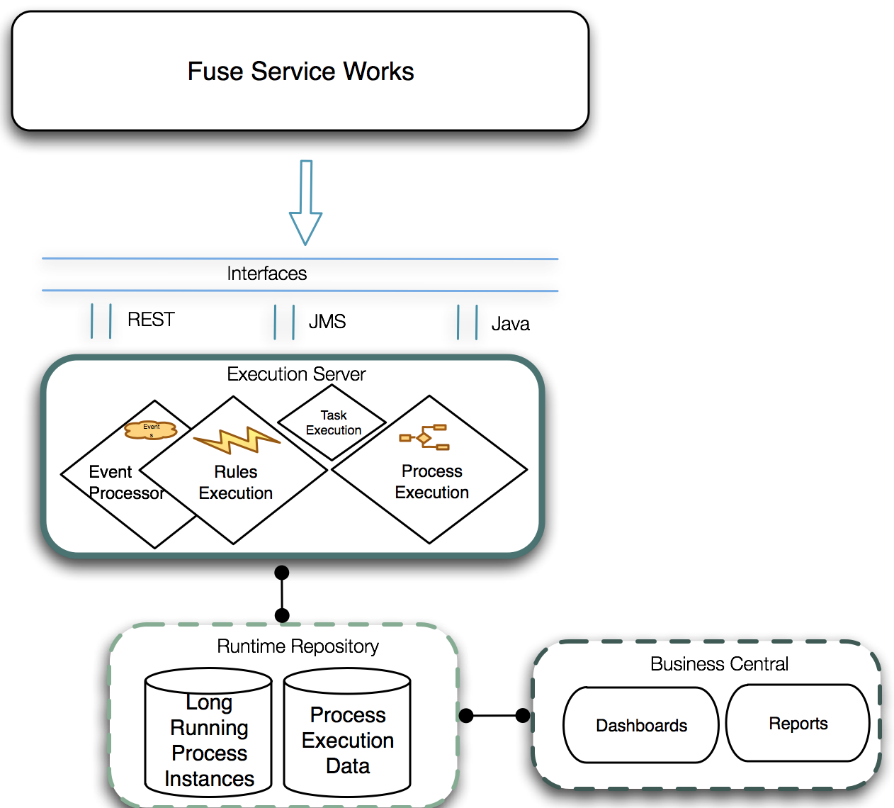

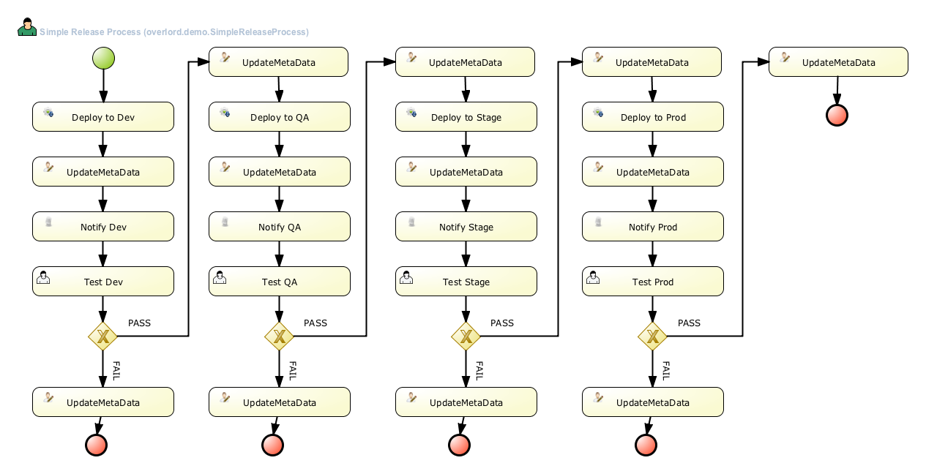
The demonstration will focus on two parts. The first is showing how Governance can help move artifacts through environments. The second is the test of the switchyard application with the camel route that calls the business process.

Technical Details of Demonstration

Fuse Service Works
The DTGov workflow is deployed to Fuse Service Works. The Switchyard application contains a camel route that calls the Business process after being invoked through a SOAP Call.
public void configure() {
// TODO Auto-generated method stub
from("switchyard://IntakeService")
.log("Received message for 'IntakeService' : ${body}")
.bean(com.example.switchyard.switchyard_example.RestClientSimple.class,"startProcess");
}

Business Process Management Suite
The customer evaluation Business Process is built and then deployed in BPM Suite.

How to Run Demonstration

Step1: Download and unzip from the github repository
Step 2: Add products to installs directory.
Step 3: Run 'init.sh' or 'init.bat'.
Step 4: For use case 1 for DTGov, Copy this code snippet into your ~/.m2/settings.xml (authorization for s-ramp repository):
<!-- Added for BPM Suite Governance demo -->
<server>
<id>local-sramp-repo</id>
<username>erics</username>
<password>jbossfsw1!</password>
</server>
Step 5: Follow the instructions on the screen to start JBoss BPM Suite server and JBoss Fuse Service Works server.
Login to http://localhost:8180/business-central (u:erics / p:bpmsuite1!).
Login to http://localhost:8080/s-ramp-ui (u:erics / p:jbossfsw1!)
Step 6: As a developer you have a modified project pom.xml (found in projects/customer)
which includes an s-ramp wagon and s-ramp repository locations for transporting any
artifacts we build with 'mvn deploy'.
$ mvn deploy -f projects/customer/evaluation/pom.xml

The customer project now has been deployed in s-ramp repository where you can view
the artifacts and see that the governance process in the s-ramp was automatically
started. Claim the approval task in dashboard available in your browser and see the
rewards artifact deployed in /tmp/dev copied to /tmp/qa upon approval:
http://localhost:8080/s-ramp-ui u:erics/p:jbossfsw1!
The example of promoting through dev to qa to stage to prod is an example of using
a local filesystem for this demo.
$ ls /tmp/dev/
evaluation-1.0.jar
$ ls /tmp/qa/
evaluation-1.0.jar
The same will take place with the Switchyard Application.
Step 7: In JBDS import the switchyard project
Step 8: Execute the Unit test to show the camel route calling the business process.
To do:
1. Issue on setting specific folder on Installation script
2. Update URLs and password on readme
3. Add link for temp for product server in init.sh
4. Add two workflows for SY and BPMS so that /tmp/<cat>/fsw and /tmp/<cat>/bpms are the same for both products. Will show moving both artifacts through environments
5. Execute deployment in SY server (Class issue)
6. change httpclient from 3.x to 4.x for rest call

